Abbreviations in Action

Use a special character to avoid unintended replacements and to harness Replace All
- Jot down abbreviations when multiple ones are being used
- Scan the text to identify repeated phrases/terms and create an abbreviation on-the-fly
- Use Edit | Find and replace (or press Ctrl+H) to replace abbreviations/errors
- Click Tools | Preferences | Substitutions to add abbreviations for the most highly used phrases

Abbreviations can be useful when composing original text
`abr is an `abr that can be used each time that `abr appears in the source text. By using an `abr, a student can save time and energy while typing and then use expansion to replace the `abr with full, recognizable text at the end of the notetaking session.

Abbreviations can be useful when copying notes from another source
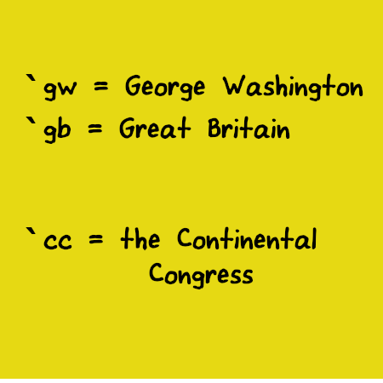
`gw began his career as a surveyor. He served in the army and had a long career in the military serving `gb. When `cc entered hostilities against `gb, `gw was called upon to serve the Colonies. `gw hoped to retire at the end of the war, but `cc had other plans when independence from `gb was finally won. `gw served as our nation’s first President.

